“Will”
Sixth Annual Group for Early Modern Studies Graduate Symposium
Friday, March 13, 2015
CALL FOR PAPERS

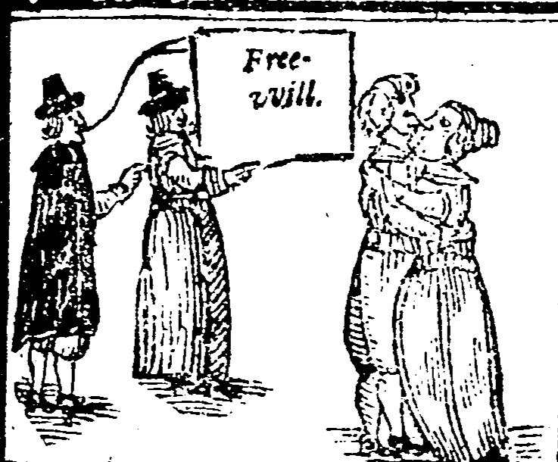
The Quakers Dream: Or The Devil’s Pilgrimage in England. London, 1655.
Early English Books Online.
KEYNOTE:
Professor Mihoko Suzuki (University of Miami)

The Wayne State University Group for Early Modern Studies (GEMS) and the Students of Early Modern Studies (StEMS) invite submissions of papers by graduate students throughout the Great Lakes region related to the general theme of “will” for our sixth annual symposium, which will be held on Friday, March 13, 2015 at Wayne State University in Detroit.
Papers might include historical, literary, cultural, legal or societal manifestations of “will,” and we encourage submissions discussing geographical regions beyond Western Europe. We define the Early Modern area broadly, from 1400-1800. The concept of “will” can be interpreted in a number of interdisciplinary ways, including philosophically (agency, autonomy); politically (absolute sovereignty, rebellion); erotically (sexual desire, chastity); textually (censorship, authorial intent); ethically (willpower, immorality); and theologically (free will, predestination).
Please submit an abstract of 250 words to gems.symposium@gmail.com by JANUARY 16th, 2015. Papers should not exceed fifteen minutes in presentation time. Please indicate A/V requirements, if any.

GEMS is an interdisciplinary working group of faculty and graduate students sponsored by the Wayne State University Humanities Center. In addition to organizing this symposium, we meet monthly to discuss primary and secondary works related to our current theme. New members are always welcome and may contact Dr. Jaime Goodrich (goodrija@wayne.edu) or Dr. Hilary Fox (hilary.fox@wayne.edu) for further information.

