**COMMENCEMENT**

College of Liberal Arts and Social Sciences

Sunday, June 12, 2016 at 8:00am

Allstate Arena

6920 N. Mannheim Road

Rosemont, IL 60018

**Instructions for ordering your *FREE* cap and gown rental:**

1. Go to <http://colleges.herffjones.com/college/depaul/>.
2. Scroll down and select **RESERVE A CAP AND GOWN**.

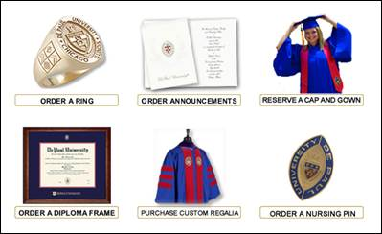

1. In the dropdown menu, select **College of Liberal Arts and Social Sciences**. Then, in the dropdown menu under **Choose your degree type**, select **Masters** if you are in a Master’s-level program or **Doctorate** if you are in the PhD portion of the Philosophy PhD program. Click **Continue**.

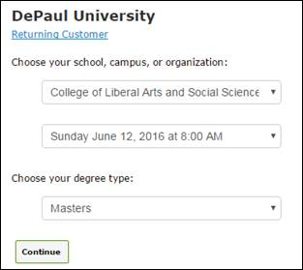

1. On the next screen, select the **ORDER YOUR GRADUATION PACKAGE!** button.

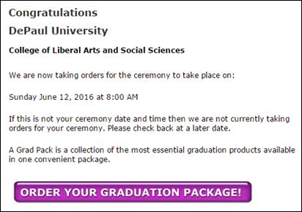

1. Scroll down and select **GRAD PACKAGE 7** to order your free regalia.

You may choose to purchase one of the other packages, which includes additional items such as a tie or graduation announcements, but the regalia rental is *no charge*.

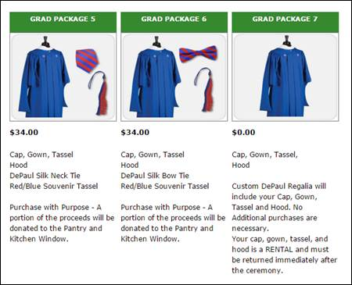

1. Fill in the correct information and hit **Add to Cart**.

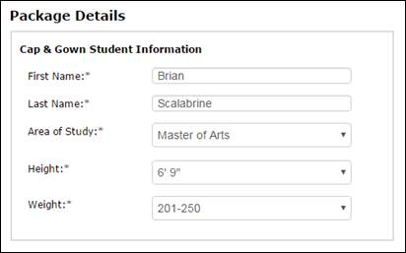

1. **Proceed to checkout** and complete the ordering process. You will receive an email confirming that your order was placed.

**All rental gowns must be returned after the ceremony. Master’s and Doctoral students must return all rented regalia except for the included tassel.**

For more Commencement 2016 related events and information, visit the Commencement website at <http://offices.depaul.edu/oaa/about/academic-affairs-events/commencement/Pages/default.aspx>.

If you have any questions, please email LAS Graduate Student Services at [lasgraduateoffice@depaul.edu](mailto:lasgraduateoffice@depaul.edu).